SAMA: Sustainability Awareness Platform

Aishah Almusalami, Fatema Alnaqbi, Roqayyah Alzeyoudi, Shamma Alkaabi, Mamoun Awad

UAE University, College of IT

{201808755, 201805835, 201807056, 201801433, Mamoun.Awad}@uaeu.ac.ae

*Abstract*— This paper investigates the awareness level of sustainability among university students in the UAE. It proposes and experiments an awareness digital platform to educate students and citizens in the United Arab Emirates on the 17 goals of sustainability. The paper presents survey results before and after using the proposed mobile application on sustainability. We demonstrate the effectiveness of the proposed digital platform in increasing awareness by conducting experiments of using the platform and analyzing survey results. Our survey results indicate that large proportion, 49% of participants, had no idea what the 17 SDG goals are. User experience of our digital platform showed that 93% of participants became aware of 17 SDG goals and were willing to contribute to achieve one or more SDG goals. Additionally, the use of our platform encouraged 75% of participants to be actively involved in SDG activities and events.

*Index Terms*— Sustainability, SDG, Awareness.

# INTRODUCTION

S

ustainability is the idea that human societies must live and meet their needs without compromising the ability of future generations to meet their own needs. The first time this word appeared was in 1987 in Brundtland report ‎[8] as a result of some international crises in ozone depletion, air pollution, global warming, and other environmental problems related to raising the standard of living. No doubt that reliance on non-renewable energy without looking for a permanent alternative will lead to the disappearance of oil, damage to the atmosphere, the absence of species of animals, the disruption of the ecological diet, and ultimately the absence of humans from life.

In 2015, the United Nations designed a collection of seventeen interlinked objectives to serve as a shared blueprint for peace and prosperity for people and the planet. Environmental Education (EE) goals were laid very early in Tbilisi Conference 1979 [15] by the international community. To address the needs for educational programs on EE in academia, academic communities developed and announced in Talloires and Halifax declarations in 1990 and 1991. As such, sustainability triad, namely, economic, social, and environmental, [14] was introduced as a framework to help students develop and apply sustainability activities in classroom and later in real life.

Although, now adays the topic of sustainability is a core requirement in many higher education programs, it is still no matured in many countries. The first essential element of achieving sustainability is public awareness of the different 17 sustainability goals ‎[9]. The awareness on sustainability is still in low rate in many countries, including the United Arab Emirates (UAE) which strives to achieve sustainability in different aspects. Recently, Expo 2020 was held in the UAE and one of the critical goals of the such global exhibition is to achieve the Sustainable Development Goals. The second essential element is the cooperation of different stakeholders including students in academia, residents, and industry. Finally, the provision of digital tools and platforms to support sustainability is a paramount element because it enables social factor in EE and leverages the use of IT technology.

In the UAE the awareness and participation among residents and students in achieving the SDGs are still low and there is a shortage of specialized tools and applications to support such activities. In terms of awareness the Government of the UAE has a website to announce and publicize different government activities and achievements of SDG ‎[10], however, a specialized digital platform on sustainability is needed to achieve the three elements, namely, awareness, stakeholders collaboration, and social factor. The use of media in raising the awareness level has been proved effective and supportive ‎[3]‎[4]. However, a dedicated mobile application is needed to involve all stakeholders including residents, industry, and most importantly focusing on young generations. Such involvement must be aligned with the standard social media applications, contribute to all SDGs, include school students very early, and have attractive features, as well as supported by the government.

In this article, we discuss a digital platform that can be used in classrooms to help students fully understand and recognize the concept of sustainability, as well as implement and contribute with different activities on sustainability. To support the success and need of our digital platform, we present a case study on the level of awareness in UAE, one of the rising countries in supporting SDGs. The case study includes surveying 367 university students to learn the level of awareness and engagement in SDGs among college students. According to our survey, large percentage, 49%, of participants had no idea what the 17 goals are. However, 97.8% of participants were willing to contribute to achieving SDGs, and 90% of participants would like to be updated with the latest UAE SDGs achievements. Overall, the study found lack of awareness on sustainability global goals. The study also proposes a mobile platform to enhance awareness, encourage engagement in SDGs, and to take active role in different societal activities. The main contributions of this work are summarized as follows.

1. We surveyed students in the UAE University, the largest institute in the UAE, regarding their awareness and engagement in SDGs.
2. We developed a digital platform in response to the students’ feedback. The mobile application design and development are based on students views in terms of usability and attractiveness, as well as it considers different age categories.
3. We surveyed students after using the mobile application and reported the awareness level improvement.

The remainder of this paper is organized as follows: Section 2 summarizes what we consider as related work to our contribution. Section 3 gives an overview of proposed solution. Section 4 describes our platform design. In Section 8, we draw our conclusions and future works.

# Related work

In this section, we present the current state of the art of research on SDGs awareness and platform development in the middle east and north Africa (MENA) region.

The use of sustainability triad, namely, economic, social, and environmental, as a framework to teach sustainability in classroom was introduced in [14]. The study showed that sustainability triad offers a pedagogical framework to well understand sustainability and its obstacles in classrooms.

The authors in ‎[16] presented systematic literature review to show that social media such as Facebook and X have high potential in widely disseminating sustainability awareness. After reviewing articles in three different online data bases, they concluded that higher education needs to utilize and tune the ubiquity of social media to extend how environmental sustainability is perceived by the students and faculty.

Kaur et al. ‎[17] investigated different factors of social media to motivate users to adopt environmentally friendly behavior. They used factor analysis and percentage analysis to process data collected through structured questionnaires. Interestingly, they found that there is a connection between social media sites usage and change in environment issue awareness level. Muhammad et al. ‎[18] found similar conclusion with the addition that such awareness can be used in enhancing environmental and government policies.

The empirical research study in ‎[19] presented the usage of social media platforms and corporate social responsibility (CSR) reports to communicate about sustainability. They examined 16 global corporations from four different industry sectors. They found that green companies are more likely to report sustainability activities in formal corporation communication.

Due to global climate change, the SDGs awareness has recently received considerable attention especially in the MENA region. Abou-Korin in ‎[1] examined the urban and environmental problems associated with rapid urbanization in Dammam Metropolitan Area (DMA) in KSA. Another study ‎[2] showed that the level of awareness on sustainability in the KSA is very low among university students. The study recommended to offer courses on sustainability and support on/off campus activities to promote SDGs, and to include other government and private stakeholders that have influence on individuals’ sustainable knowledge and behaviors.

The authors of ‎[3] discussed, surveyed, and analyzed the role of digital media in achieving sustainable development in the Arab World. One main recommendation is to utilize digital media in providing information relevant to environmental development events and plans to successfully achieving their goals. Susilawati and Surf ‎[4] explored and examined public awareness of sustainable housing in Saudi Arabia. Survey analysis found that more than 50% of participants were not aware of sustainable housing, and recommended to further educate the public by using local media to inform people of the benefits of sustainable implementation to both new and existing housing stock.

Batch et al. ‎[5] explored and analyzed stakeholders’ perceptions of the development priorities in the UAE. They suggested more effective strategies to assist sustainable economic growth in the United Arab Emirates (UAE). The study revealed that respondents prioritize the economic development factors over sustainability factors; hence, a media campaign could be developed and executed to increase sustainability awareness. The authors of ‎[6] found that increasing social awareness is critical in achieving sustainable procurement in the public sector in the UAE. In a study by Muhammad et al. ‎[7] on identify factors of consumers’ awareness about organic food, the authors found that awareness of organic food among UAE national is higher than non-national due to lower income. The study found that awareness of organic food is essential for farmers to create greater market share.

In terms of applications and platforms relevant to sustainability, very few applications were developed in the MENA region. In the following we summarize popular platforms along with their features ‎[11]. “Think Dirty” is an application that tells whether ingredients were sustainable or not. “Good On You” is an application that ensures that the worn clothes were sourced, designed, and produced with the environment in mind. The app also allows users to add new brands to the directory, message brands, and receive suggestions for sustainable clothing alternatives. “Oilo” is an application to prevent food wastage, share the food in the app and the neighbors will contact you to pick it up. “My Little Plastic Footprint” suggests sustainable alternatives for the plastic items that are a part of your everyday life. “Refresh go Green” seeks to help users turn home into a greener environment, as well as indications about each person's diet, health, or daily habits. “Good Guide” makes it easy for you to find ethical and environmentally-friendly products on the go. It provides scientific health, environmental and social ratings on a huge database of products.

The above applications are very general, used individually, and lack usability and attraction features to encourage users participate, contribute, and share in sustainability activities, as well as get informed of SDG activities in the country.

This paper is similar to the work in ‎[1] and ‎[2] since it explores the awareness level of people on SDG through conducting and analyzing surveys. However, our work is different because it focuses on the social factor in UAE and provides solution to improve awareness by developing and presenting an SDG platform rather than recommendation.

Our App: The goal of the application is to achieve the 17 sustainable development goals that the user shall complete by accomplishing different challenges. For each goal, there will be different actions related to that goal. The user has a choice of choosing the goals that she/he is interested in and what they would like to achieve. As a result, users will get scores, and based on it they will be ranked and the top 10 users with the highest scores will be shown to other users, for each challenge users shall post a picture and share it with others. Users will be able to like/dislike others' posts.

# Awareness Level analysis

We conducted a survey targeting different age categories in the UAE. The survey questions attempt to identify the level of awareness on SDG and different ways to improve that. In the following paragraphs we analyze and summarize our findings. The reader can find detailed findings and statistics in ‎[12].

We received 367 responses 86.4% are from the 15-30 age category. 92% of responses was UAE national, which is consistent with ‎[3]‎[4]. In terms of employment, the distribution of the responses was 60%, 28%, and 5% for college students, school students, and employee, respectively. In terms of awareness of the 17 goals, 49% of participants were not aware of SDG goals. However, 97% of participants showed interest in contributing to sustainability through different activities. The survey showed that 74% of participant indicated that they did not use any application related to sustainability and/or participated in any activities.

In conclusion, the level of awareness on SDG needs dramatic improvement. We found that students and youngsters are mostly interested of the future of SDG in UAE. Additionally, citizens are more interested than residents due to different level of living standards between them. Moreover, the top SDGs identified as national goals to achieve are: “No Poverty”, “Gender equality”, and “Clean water and sanitation”. Finally, we conclude that an application or platform is of high need to help the UAE residents to participate and engage in SDG activities. The application will be used to increase the awareness of different SDGs and the activities related to them on different private, public, and government sectors.

# Methodology

Based on sustainability triad and supported by the survey we conducted, see Section ‎III , we present our research methodology to improve and involve students and citizens in SDGs. Recall that the social factor is one pillar of sustainability triad; hence, we must strive to have students and other stakeholders socially involved in this. In addition, according to the survey we conducted, 74% indicated the need for specialized socially integrated platform on sustainability. Moreover, the UAE citizens and residents are very active on the social media ‎[20]; hence, the introduction of socially accessible platform will be appealing by the users to be used. Figure 1 presents Sama as the centralized platform in which different stakeholders connect and use for sustainability events. We know that different government and private entities have their own general websites, however, we need a specialized platform that connect all entities’ activities, news, and achievements of sustainability, and present them to the public. This way, global events, such as COP28, become very popular and easy to find when individuals read on it in Sama’s landing page.

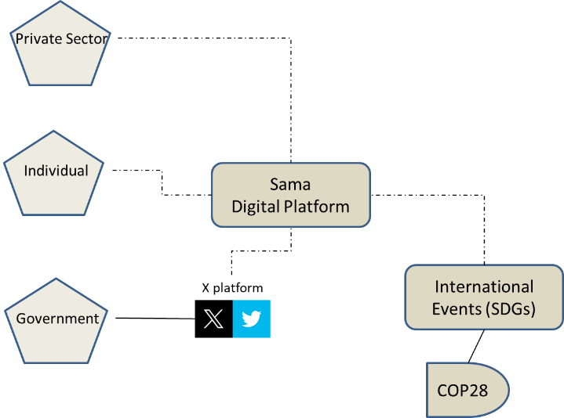

Figure 1 Stakeholders of SAMA digital platform

The sharing of SDG activities at schools and universities can contribute heavily on encouraging students to participate and actively compete for green environment. Figure 2 presents an extension usage of Sama to be used in classrooms and universities. Faculty and teachers can create project space and students can post their experiences on that space. This way, innovative activities and/or personal experiences are shared and made available for public to like, reward, etc. Notice that access restrictions can be imposed by the owner of the space such as teacher or faculty.

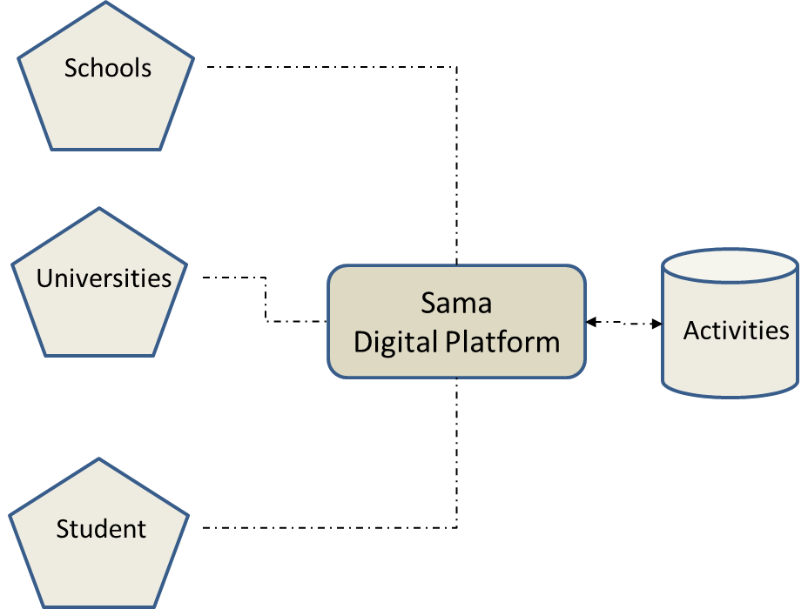

Figure 2 Integrating SDG in schools

## Mobile Platform design

SAMA is a mobile application of two folds, firstly, to encourage UAE residents to engage in SDG, and secondly, to spread the awareness on SDG among the community. Briefly, the application has the following screens: registration, login, interests, profile updates, notification, goals awareness, like/dislike/points/encouragement, search, and contribution to sustainability, see Figure 3. The use case model is a standard diagram that follows Unified Modeling Language (UML) in which functions/features and main participants are identified.

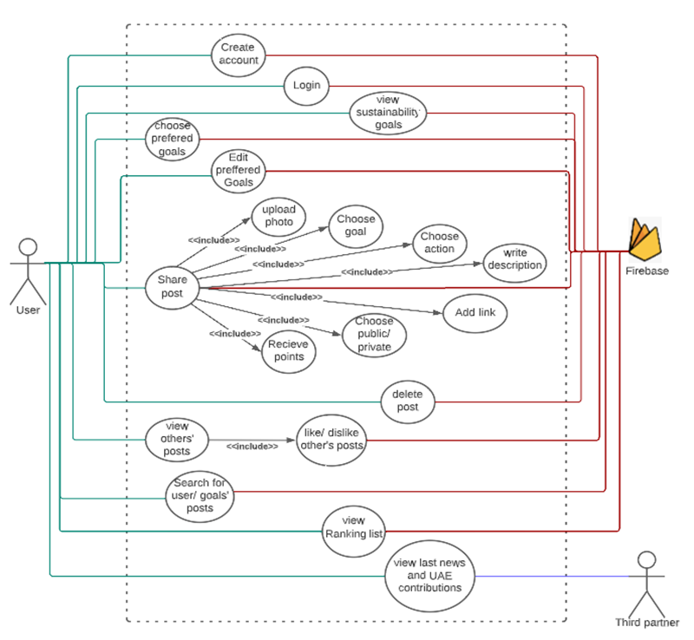

Figure 3 Use case model of SAMA.

The stickman notation represents actors. Actors are external entities that interact with SAMA. We have 3 actors, namely, user, firebase DB, and third partners. These actors interact with SAMA in different functions and modeled in ovel notation in Figure 3. Brief descriptions of the use cases are presented in Table 1. The reader can find more details of SAMA use case model in ‎[12].

Table 1 Use case brief description

|  |  |
| --- | --- |
| Use Case | Brief Description |
| Login/Logout | User can login/logout to the application. |
| Register | User can create new account |
| SDG Selection | User can view and select her preferred SDG goals. |
| Post/View Activity | User can post their activities through photos, videos, etc. Other users can view them, like/dislike, and comment on them. The “like” will be used as points to decide top SDG activities. |
| Search Posts | User can search for posted activities by other users. |
| View News | User can view recent news on activities. News are based on SDG government account on twitter (“@uaesdgs) and other official web sites. |

## Data Architecture

The architecture of the platform is shown in Figure 4. After downloading the application, users can communicate through standard Internet connection to share posts, and comment on SDG activities. The backend of the data is Google Firebase repository ‎[13].

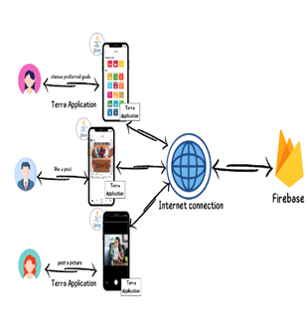

Figure 4 SAMA architecture

The Firebase is a NoSQL cloud database that applications can share data and exchange information in real time. The data architecture of SAMA is presented in Figure 5. In terms of data representation, we stored objects in a single large JSON tree structure which is updated regularly in real time. For retrieval, we use two structures to retrieve the data quickly. Specifically, we have multiple users in the first structure. Each user will have posts, score, email, profile photo, phone number, username, name, password, interests and notifications. Under the notifications, we have post flag, post id, text and user id. Under the posts there will be all the user posts with a unique ID. Each post will contain action, description, goal, goal id, image, likes, dislikes, points, post id, private, and publisher, see Figure 5.

The main data elements that are used in the application are presented in the Table 2.

Table 2 Description of SAMA main classes/entities.

|  |  |
| --- | --- |
| **Entity/class** | **Description** |
| **User** | User’s information such as username, name, Image, and score. |
| **Post** | Post holds the post information such as image, goal, action, description, link, private, point, like, dislike, publisher, and post id. |
| **Goal** | Contains the SDG Goal information such as goal ID, description, logo, logo label, actions, and link, see [link](https://sdgs.un.org/goals). |
| **Notification** | Holds notification information as attributes such as user Id, text, post Id, and is-post. |
| **Account Manager** | Manages current user information and sharing it between the activities. |
| **Goal Manager** | Holds, retrieves, and manages SDG goal information such as goal id, goal name, goal icons, goal info, actions, and link and share it between the classes. |
| **UI** | The user interface will combine all the classes' functions in a user-friendly interface that is easy to use. |

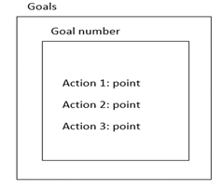

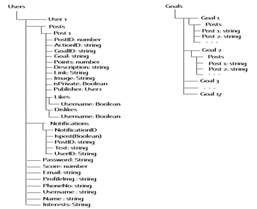

Figure 5 SAMA Data Model (Cloud Firebase)

## User Interface Design

SAMA is very user friendly and the usability level is very high. Most users did use it directly without any help due to following standard HCI (Human Computer Interaction) design principles, and considering the feedback from users in the surveys. Figure 6 presents the UI screens and the Table 3 presents a brief description of each screen. The UI was designed using Figma and PowerPoint, and deployed on Android Studio as XML.

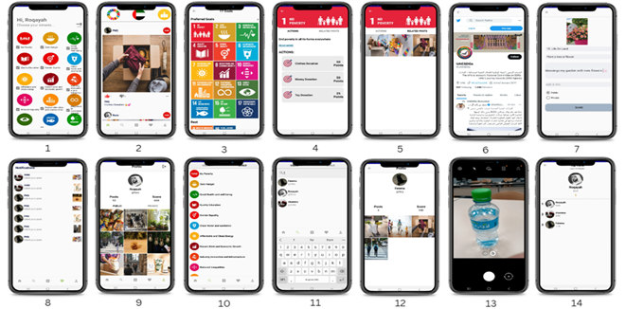

Figure 6 SAMA UI screen shots

Table 3 UI screen brief description

|  |  |
| --- | --- |
| **Screen number** | **Description** |
| 1 | User selects her interest goal from the 17 goals. |
| 2 | The main page of the user. |
| 3 | The page of all goals with user-selected interests is on the top. |
| 4 | The page of a certain goal with a description, access to all posts related to this goal, and actions to do with this goal. |
| 5 | The related post to goal 1. |
| 6 | The page shows the latest UAE contribution in the sustainability field and activities. |
| 7 | New post page where the user can write the description and choose the goal and action. |
| 8 | A page that shows a notification when users interact with each other’s. |
| 9 | Profile of the user displaying posts and scores. |
| 10 | Search page with the option to search by a goal to see related posts. |
| 11 | Search page with the option to search by users to view users’ profile |
| 12 | Viewing another user profile. |
| 13 | Posting page where the user can take a picture or upload his action. |
| 14 | Ranking page of all users displaying results every 24 hours and a week. |

# analysis and Results

SAMA is implemented in JAVA using Android Studio IDE. It consists of 38 java classes, filled with around 7273 lines of code, which is equivalent to 286 KB, and 65 XML classes/files filled with around 4037 lines of code, which is equivalent to 155 KB. The whole project size is 129 MB. The code, documentation, and the manual are public and can be accessed on GitHub ‎[12].

To test the usability and awareness effectiveness of the application, we installed SAMA on several mobile devices, and distributed them on a random sample of 34 persons in the 17-30 age category. The participants used the application independently for 7-30 days. We report the user experience of the sample as follows. More than 93% of participants rated their awareness experience with SAMA as 4-5 where 5 indicates fully aware of SDGs, see **Table 4**. Observe that 75% of participants ranked their awareness of SDGs as 1-2, where 1 is not aware.

Table 4 Level of awareness of SDG (scale 1-5) before and after using SAMA

|  |  |  |
| --- | --- | --- |
| Level of Awareness | Before | After |
| 1 Not Aware | **30%** | 0 |
| 2 | **45%** | 3% |
| 3 | 18% | 6% |
| 4 | 3% | **27%** |
| 5 (Fully Aware) | 3% | **67%** |

84% of participant indicated that SAMA is easy-to-use and user-friendly platform and they rated its usability as excellent or very good. 73% of participants indicated that they will recommend the application to other colleagues or family members, see **Table 5**.

Table 5 Survey response on the recommendation of SAMA to a friend.

|  |  |
| --- | --- |
| Recommend Sama to Friend | Percentage |
| Not recommend (1) | 0 |
| 2 | 5% |
| 3 | 3% |
| 4 | 8% |
| **Highly recommend (5)** | **73%** |

# Ethical Considerations

The study has received the ethical approval from the research office of the UAE University to protect rights and the confidentiality of the students. Prior to the starting of the survey and the experiment, the authors explained to the students the procedure and the usage of the application on the mobile. The purpose of the study was not explained in advance so as not to influence students’ responses. Students were instructed that they can discontinue participation or decline to respond to any of the questions in the survey. All students provided spoken informed consent.

# Conclusion and future work

In this paper, we investigated the awareness level of sustainability in UAE. We analyzed the survey results on how to engage students and residents in different activities and actions of SDG. Unfortunately, the awareness level is low and people especially students need encouragement and more engagement. The authors proposed SAMA as mobile platform for residents to improve awareness and encourage young generation on participating in SDG by sharing their different activities and contributions on SAMA. The application was tested and evaluated by the authors (development team) and finally tested by the users in terms of functionality and usability. The authors conducted another experimental survey in which the application was disturbed among random sample and the participant used the application about 1-4 weeks. The application usability seemed very high and students described it as easy/enjoyable to use. In terms of awareness of SDG, the awareness level increased dramatically from 75% (not aware) to 94% (well aware) which indicates that such platform will help the UAE in spreading SDG awareness especially among university students and young generations.

In the near future, we plan to extend this research by studying SDG activities and projects at schools. By adding the classroom space feature, faculty/teacher can post SDG projects themes, and students can post their innovative activities and contributions on that theme. We will study the effect of school projects in the classroom space and measure the awareness among students.

We also plan to add the social accounts registration feature so that government/private entities can share their achievements and make it visible on SAMA either by searching and/or sharing.

# Recommendation and Future implications

1. Universities and schools have the biggest role in promoting awareness on SDG in the UAE.
2. Government is recommended to include sustainability activities and knowledge in the early grades at schools and make it part of in/out class activities.
3. Standard courses on sustainability need to be mandated to be offered in colleges. Although UAEU, the biggest institute in UAE, has a general education course on sustainability, level seems low among other students in the country.
4. Government needs to support national platforms to improve awareness and engagement in sustainability activities.

# Limitation of the study

In this paper, we investigated the awareness level of sustainability in UAE. We analyzed the survey results on how to engage students and residents in different activities and actions of SDG. Unfortunately, the audience of our study is college students. therefore, we can not possibly use the results to draw conclusion of level of awareness in schools, private/public sectors. This study focused on the role of universities in enriching students’ sustainability literacy and influencing additional SDG supportive activities and actions.

Also, a follow up method by other researchers could possibility improve the participants’ professional behavior in sustainability to include other parameters to the survey such as program study, year of study, and gender.

# Acknowledgement

This research is funded by the United Arab Emirates University research grant number 2609.

References

1. Abou-Korin, Antar A. "Impacts of rapid urbanisation in the Arab World: The case of Dammam metropolitan area, Saudi Arabia." 5th Int’l Conference and Workshop on Built Environment in Developing Countries (ICBEDC 2011). Pulao Pinang, Malaysia: University Sains Malaysia, 2011.
2. Alsaati, Tasneem, Samir El-Nakla, and Darin El-Nakla. "Level of sustainability awareness among university students in the eastern province of Saudi Arabia." Sustainability 12.8 (2020): 3159.
3. Al Sheikh, Hanan Esmaeel, and Faisal Ahmad Al Serhan. "Role of digital media in achieving Sustainable Development in the Arab World." Saudi J. Humanities Soc Sci 7.5 (2022): 177-187.
4. Susilawati, Connie, and Mohammed Al Surf. "Challenges facing sustainable housing in Saudi Arabia: a current study showing the level of public awareness." Proceedings of the 17th Annual Pacific Rim Real Estate Society Conference. Pacific Rim Real Estate Society, 2011.
5. Pejić Bach, Mirjana, et al. "The economic and sustainability priorities in the United Arab Emirates: conflict exploration." Journal of Enterprising Communities: People and Places in the Global Economy (2023).
6. Al Nuaimi, Bader Khamis, Mehmood Khan, and Mian Ajmal. "Implementing sustainable procurement in the United Arab Emirates public sector." Journal of Public Procurement 20.2 (2020): 97-117.
7. Muhammad, Safdar, Eihab Fathelrahman, and Rafi Ullah Tasbih Ullah. "The significance of consumer’s awareness about organic food products in the United Arab Emirates." Sustainability 8.9 (2016): 833.
8. Keeble, Brian R. "The Brundtland report:‘Our common future’." Medicine and war 4.1 (1988): 17-25.
9. "The 17 Goals". Sustainable Development Goals. UN, <https://sdgs.un.org/goals>
10. UAE National Committee of SDG, <https://sdgsuae-fcsa.opendata.arcgis.com/>
11. L. Serges, "Top 10 Mobile Apps That Promote Sustainability", Blog.hylamobile.com, 2021. Available online: <https://blog.hylamobile.com/top-10-mobile-apps-that-promote-sustainability> . [Accessed: 25- Apr- 2022].
12. GitHub link to the [survey 1](https://github.com/mxawad2000/SGD_2022_SAMA/blob/main/Appendix%20A-Survay%20analysis.pdf)
13. Moroney, Laurence, and Laurence Moroney. "The firebase Realtime database." The Definitive Guide to Firebase: Build Android Apps on Google's Mobile Platform (2017): 51-71.
14. Herremans, Irene M., and Robin E. Reid. "Developing awareness of the sustainability concept." The Journal of Environmental Education 34.1 (2002): 16-20.
15. Intergovernmental Conference on Environmental Education, Tbilisi, USSR, 14-26 October 1977: [final report](https://unesdoc.unesco.org/ark:/48223/pf0000032763)
16. Hamid, Suraya, et al. "Social media for environmental sustainability awareness in higher education." International Journal of Sustainability in Higher Education 18.4 (2017): 474-491.
17. Kaur, Amandeep, and H. S. Chahal. "Role of social media in increasing environmental issue awareness." Researchers World 9.1 (2018): 19-27.
18. Mohammed, Abeer Abdullah Abdulmajid, and Dhanapal Durai Dominic. "Social influence on the use of social media towards environmental sustainability awareness in HEI." 2021 International Conference on Computer & Information Sciences (ICCOINS). IEEE, 2021.
19. Reilly, Anne H., and Katherine A. Hynan. "Corporate communication, sustainability, and social media: It's not easy (really) being green." Business horizons 57.6 (2014): 747-758.
20. UAE Social Media Statistics on Meltwater.com: <https://www.meltwater.com/en/blog/social-media-statistics-uae>